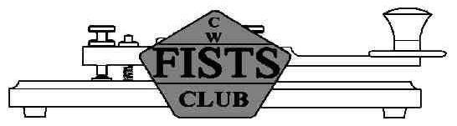
1.810
1.838
1.836
QRP
1.818

824
831
817
540
560
520
3.500
3.580
3.560
QRP
3.558

7.000
7.040
7.030
QRP
7.028

020
030
010
120
130
110
10.100
10.140
10.118

10.116
QRP
510
14.000
14.070
14.060
QRP
14.058

035
053
018
081
088
075
18.068
18.095
18.086
QRP
18.085

14.055
QRS
18.096
QRP
21.000
21.070
21.060
QRP
21.058

035
053
018
21.055
QRS
28.000
28.070
28.060
QRP
28.058

035
053
018
28.055
QRS
903
909
896
24.890
24.915
24.906
QRP
24.918

090
095
085
50.080
50.100
50.090
CW
144.035
144.110
144.058

073
091
054
144.050
CW
70.050
70.250
150
200
100
70.200
CW/SSB
70.085
PSK31
70.150
MS
144.100
MS
160m
80m
40m
4m
10m
15m
20m
2m
17m
30m
12m
6m
CWCW centre of activity
MSMeteor Scatter

050
250
035
QRPQRP centre of activity

CW & FISTS Activity Centres (UK)
000
000
000
000
810
500
100
068
890
080
838
070
070
070
580
140
095
915
100
110
040
10.106
QRP
QRSSlow speed centre of activity (Source: RSGB band plan)

Primary telegraphy area (Note: 4m shares primary area with SSB and other narrow band modes)
Within amateur band but not primary telegraphy area
29th September 2009
DX only

